**Central Control Unit**

This unit is responsible for the control and management of the Home Energy Management System. It’s functions include:

* Retrieving the Time of Use pricing information from the Utility Portal
* Retrieving Temperature readings as well as sending control signals to Thermostat subsystem Heater and AC
* Optimization, scheduling and sending control signals to the Device Energy Manager
* Receiving Current and Voltage Measurements from the Device Energy Manager and Computing total energy consumption and cost

Components:

* Raspberry Pi 3B
* 7 inch Official Raspberry Pi Touchscreen Display
* Xbee s2c RF module

Software Architecture Overview:

The Central Control Unit Application Development is done using Python, it consists of a Graphic User Interface developed using the Kivy Framework. Kivy is an open-source cross-platform development python framework using for the development for touch screen applications. The various IO interface and time of use data retrieval is done using python threaded classes that interface and communicate with the system through queues. The figure below shows the high-level system overview.

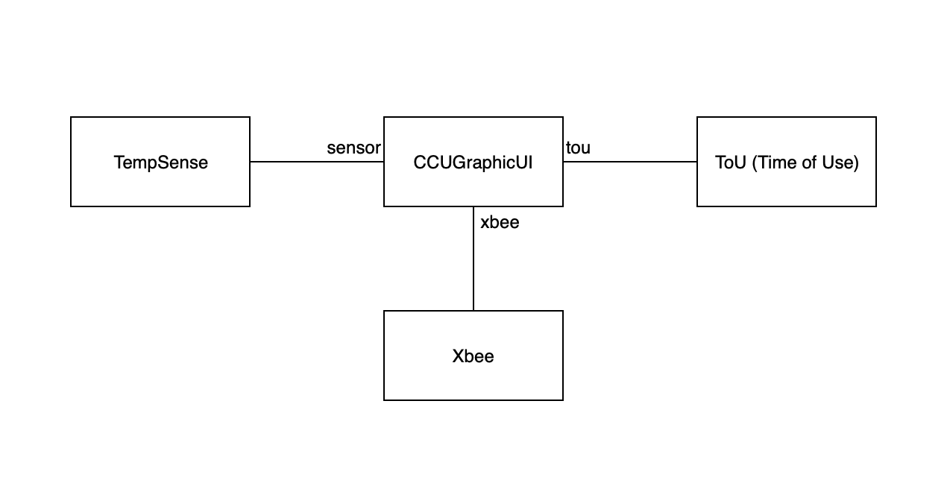

*Figure 1: High level system overview*

Wireless Communication:

Protocol: **802.15.4**

Radio: **Xbee s2c**

Interface: **USART**

Baudrate: **9600 bps**

Optimization Model:

Price: Π(t)

Charging Power: P(t)

Minimize $Σ P\left(t\right)×$ Π(t)

Subject to: $0 ≤P\left(t\right)≤$ Pmax